**Question 1.**

Follow the steps in “Setting Up The SD Card Activity Sheet”. At the end of activity, take a screenshot of the Serial Monitor and include here.

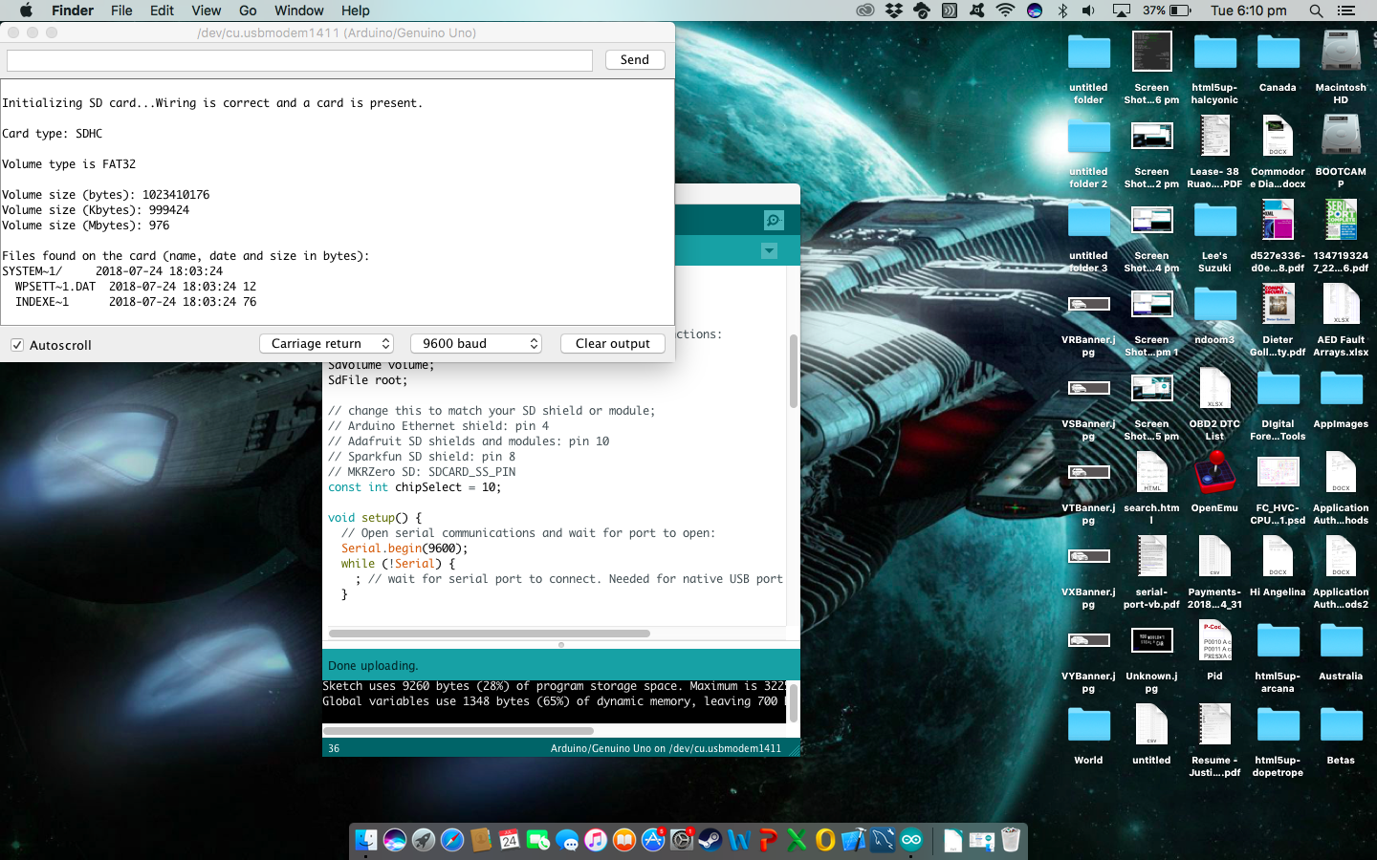

**Question 2.**

1. Follow the steps in “Using the Real Time Clock Activity Sheet”.

At the end of activity, take a screenshot of the Serial Monitor and include here.

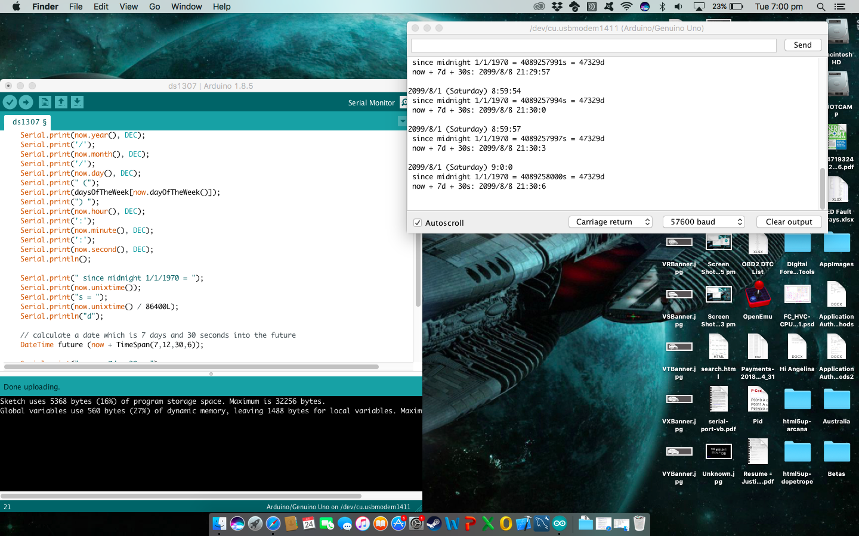

1. Examine the code. What does the following line of code do?

DateTime now = rtc.now();

DateTime now = rtc.now() does two things, the first rtc.now() returns the current time since midnight Jan 1 1970 (UNIX Time) in seconds, the second sets the DateTime variable “now” as the result of rtc.now

**Question 3.**

1. Now you are ready to start logging data to file! Follow the steps in “Saving Motion Data Activity Sheet”.

At the end of activity, take a screenshot of the Serial Monitor and include here.

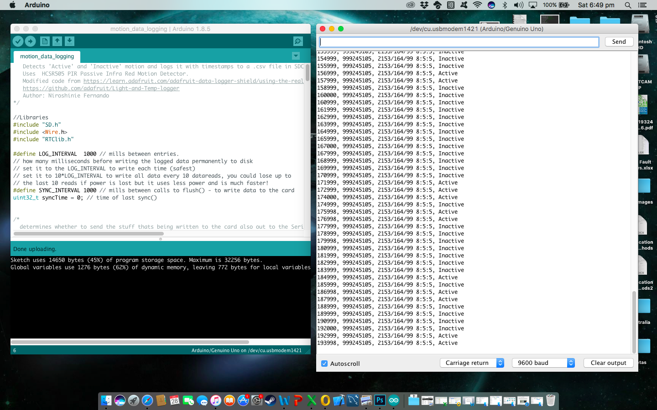

1. Run your program. Wave your hand in front if the motion sensor and observe the ‘Active’ state, then stop and wait until you see an ‘Inactive’ state on the Serial Monitor. Keep doing this for three minutes so that you get both ‘Active’ and ‘Inactive’ data. At the end of three minutes, unplug the USB. This will switch off the Arduino board. Next, retrieve the .csv file containing motion sensor data from the SD card. Upload the .csv file with this report to unit site.